Sam McDowell

7/10/2020

Lab 4-1.2

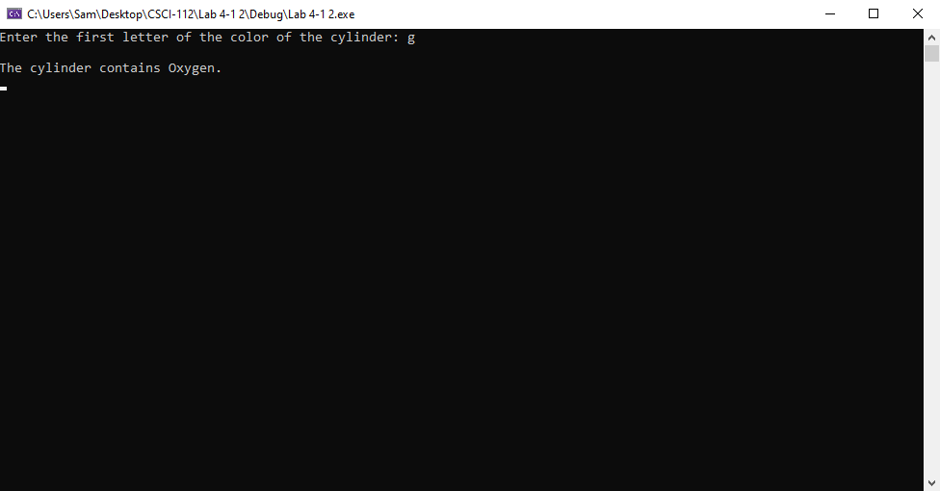

# Transcription:

Enter the first letter of the color of the cylinder: g

The cylinder contains Oxygen.